Rule 1: Strive for consistency
Overall, the design maintains a consistent drag-drop interaction across Pages 1-3. In the landing page (Page 1), a drag-drop approach is used to insert cards into a “Debate Pond”, this is replicated in Page 2 and 3 when planning. Additionally, users can pinch to zoom in on the cards, as noted in Page 1, further enforcing the touch and drag interaction nature. This provides a coherent experience, as users won’t be momentarily confused by a sudden new way of interaction, reducing re-learning and supports motor memory. The verbs/terminologies used throughout the app are also consistent. User plans (aka “tracks”), crowd level (“crowd”), “wait time” are maintained throughout all pages, avoiding synonym confusion. Overall visual layout is consistent, following a card-based design with cards being clustered around centre of the screen where the primary focus area is (Page 1-3).
There is inconsistency in the primary action button of the cards. Most cards use the bottom-left corner for interaction buttons, but the plan cards in Page 4 uses bottom-right instead. This may annoy users as their muscle memory is used to interacting in the bottom-left area. An improvement is to standardise the primary interaction corner (e.g. bottom-left) across all cards.
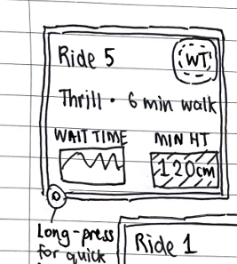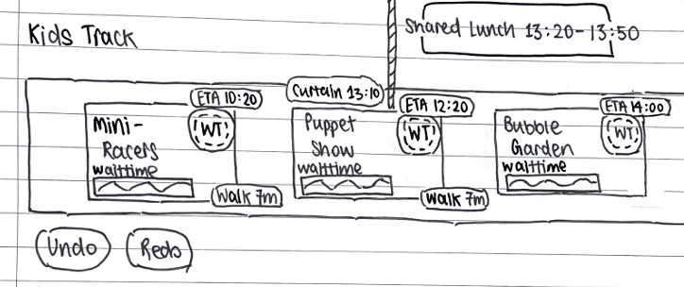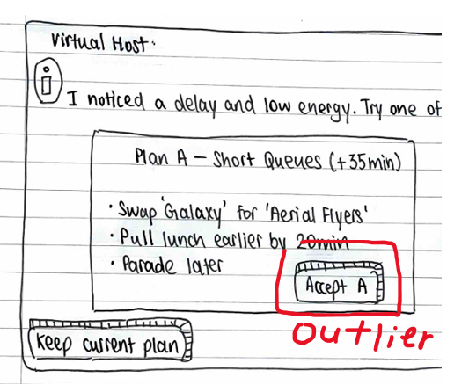

Rule 2: Cater to universal usability
The design lacks a language switching functionality, which impacts readability for users whose primary language are not English. Including a language switch button would address this.
The design is largely readable. Buttons for the cards and filter options in Page 2, 3, 4 are large, easily readable, and use laymen language. This allows users to quickly understand the purpose. In Page 1, it is stated that long-pressing the card will reveal more details. However, the discoverability of this feature for new users is low without explicit training/information. Adding a more obvious “show more details” button/chevron icon allows for easier access to details instead of reliance on a hidden feature.
Plasticity is demonstrated via pinch-to-zoom on destination cards (page 1) to allow users to magnify the card size to a level they are comfortable viewing at. Information density of the cards is customisable through long-pressing the cards to view more “quick facts”.
There is good support for new/novice users, such as one-click buttons in Page 4 that allows for quick changes to plans. The overall drag-drop design is intuitive to understand and easy to use.
The same support for novice users may however impact more advanced users. It is not immediately clear from the sketch if advanced users are able to more finely control the ordering of the plans, rather than simply accepting the system’s preset suggestions. Adding a method to allow for adjustments to system suggested presets would address this.
Support for people with disabilities are also present, although more specific to visually impaired group than others, via the read options aloud functionality present across all pages.
Rule 3: Offer informative feedback
Common actions such as user touches are offered immediate feedback via a user-specific coloured pebble cursor. This confirms user inputs and helps to distinguish touches between the multiple different users. In Page 3, the designer’s notes provide for substantial feedback in event of errors (e.g. a red badge appears with suggested workaround in event of height restrictions). Accepting a plan in Page 4 also provides an animated transition that acknowledges success for user input.
Consider adding some toasts/badges for filter applied, dropping/undropping cards into valid/invalid areas (e.g. debate pool), saved changes etc. to better inform users on the result of their actions.
Rule 4: Design dialogs to yield closure
The application has a logical sequence of actions to take from page to page. Starting with selection of destinations in Page 1, followed by further filtering in Page 2 and finally re-ordering and confirmation of the plan in Page 3. This supports the beginning-middle-end structure. However, there is no visible step indicator, hence a new user does not have an overview of where they are and what is to come. An improvement would be an addition of a banner at the bottom of the application to show which step he is at (debating/planning/confirmation etc.).
It is not immediately clear from the lo-fi sketch how does one navigate from one page to another. E.g. Page 1 (selection of destinations) to Page 2 (debate) as there are no confirmation dialog/buttons for users to confirm they are done with the previous step. Simply adding a done/apply button at the end of each phase would remedy this.
Rule 5: Permit easy reversal of actions
The design generally allows for intuitive reversal of actions intra-page wise. For example, in Page 3 users can undo their last action when planning by using the undo button. In Page 1, users can easily add/un-add a destination to the debate pond by dragging in/out of the allocated area.
Following from Rule 4, it isn’t immediately clear how does one revert to the previous page (inter-pages). Suppose a user finished adding destinations to the Debate Pond in Page 1 and is now in Page 2 for further filtering. Should the user have a sudden change of mind and want to add more destinations for debate, there is no apparent button to press to revert the view to the previous page. This issue is repeated in Page 3, where there is no apparent method to go back to Page 1/2 to add more destinations. In Page 4, once a user accepted a system suggestion, should they have a change of mind, they are unable to revert to their previous plan/go back to Page 3 to further customise the plan based on the system’s suggested preset changes. An improvement would be to add a persistent “Back to previous step/page” button across the pages would allow for recovery efforts/actions.
Rule 6: Support internal locus of control
The design reduces dissatisfaction among users by eliminating repetitive confirmations for common actions and keeping friction between routine edits low. The drag-drop nature of the application eliminates the need for incessant pop-ups. This is evident in Page 1 and 2, where users simply need to drag cards to allocated areas to assign a tag/status to them without the need for confirmation each time (e.g. in consideration/not). Page 3 also allows for easy re-ordering of the plans via dragging instead of needing to perform multiple tedious button presses.
The proactive suggestions on Page 4 mostly guard against acausality. The proactive feature of the design merely suggests actions to the users to take, along with a dismiss function, rather than actively altering the plans without user intervention, providing user with control over their plans. However, it is not immediately clear from the sketches if Page 1/Page 4 will first greet returning users at mid-day when they “scan again to resume”. Does it first show Page 1 and prompt the user to resume their plan and transition to show the alerts on Page 4? Or immediately shows Page 4 to alert users to unforeseen circumstances? The resume behaviour could be better defined, such as when returning on mid-day land on page 4 only if user explicitly opted to auto-resume, else return to the last active step. If this was already intended case, then there are no issues.
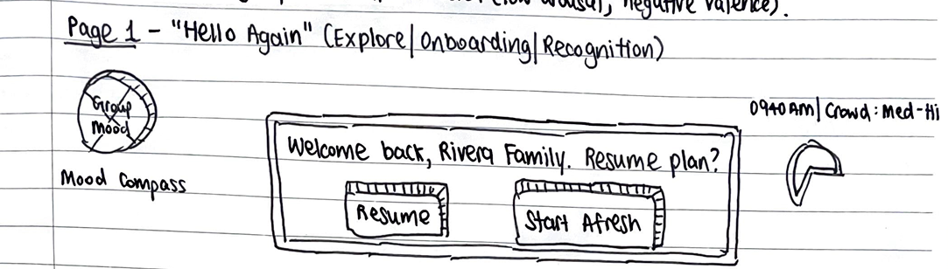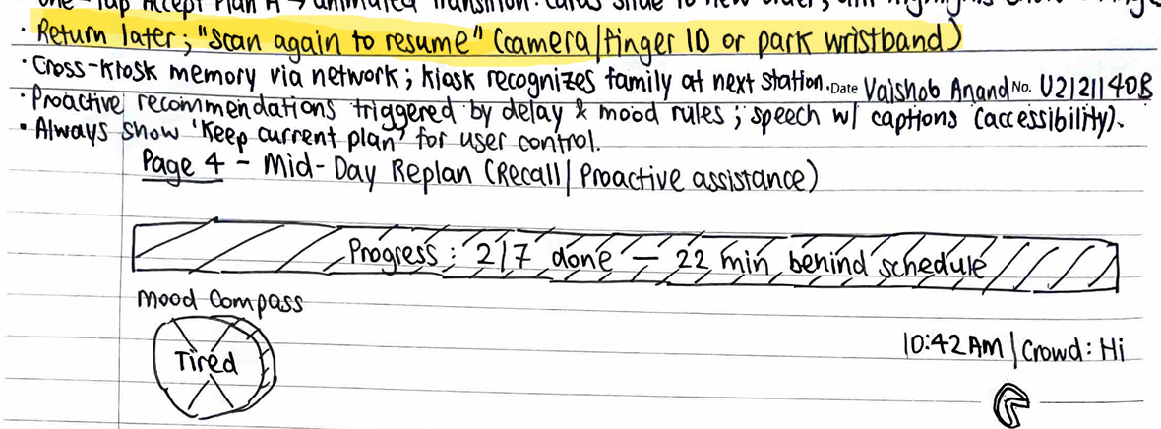

Rule 7: Reduce short term memory
Memory load on the users is kept low throughout the design. Buttons and icons are labelled, and no abbreviations are present in the design. Large cards with key facts are visible (wait time, distance) so users don’t have to open/close details to remember. Each page has a dedicated purpose, fulfilling one aspect only (Page 2 is filtering, Page 3 is planning etc.) so users don’t get overwhelmed.
Cross-screen memory is minimised by persisting relevant states across pages. For example, the destination cards’ details are kept consistent and appear across pages 1 to 3, so users need not memorise details. Generally, the current track itinerary also appears consistently (bottom of Page 1 and separately in Page 3). It is not clear from the sketch if this track itinerary appears in Page 2 (the dotted box at the bottom). An immediate improvement would be to include the same track itinerary on Page 2 to keep it consistent all 3 pages so users can immediately recall/see the overview of the current plan at each step of the user flow.
Rule 8: Prevent errors
Design prevents user errors well by enforcing clear affordances and constraints. Again, there are obvious labelled zones to drag/drop items. The destination cards are also large, and well-spaced to avoid mis-taps, which is further enforced by the pebble cursor feedback as stated earlier so users have secondary confirmation on their touches. Following from Rule 7, the single-purpose nature of the pages (especially the simplistic Page 1 and 2) leaves little room for errors since users have little leeway to perform actions out of the system’s constraints. As noted earlier in Rule 2, Page 4 offers simple one-click buttons for plan changes. Although this prevents more advanced fine-tuning of the plans, it also prevents users from performing unexpected changes outside of system parameters. A balance needs to be strike between Rule 2 and 8, as we want to still afford advance users the ability to make fine changes, while preventing errors from novice users. A suggestion would be to implement an advanced plan fine-tuning button on Page 4, which leads to the guarded Page 3 (see below paragraph).
Risky states are detected, blocked early and offer explanatory handling. This is evident in planning mode in Page 3, where guardrail badges with suggested workarounds appear when a user performs an impossible task (i.e. height restriction or impossible timings) as stated in the designer’s notes, thus preventing users from making invalid actions. A possible improvement would be to grey out inapplicable filters/actions and constrain inputs in the first place as opposed to throwing a badge.
Additional Comments
The sketches feature many touch-based interaction that may not be visible to users on first glance, adding a first-run onboarding with some 10-15 seconds guided hints for touch manoeuvres (pinch, drag-drop, long-press) would help. A persistent Help icon to replay would also improve usability.

